**SQL_Views Assignment**

***Note*:** This assignment has to be completely performed in MYSQL Workbench. Select your OS type and download workbench from the given link. <https://dev.mysql.com/downloads/workbench/>

The version of MYSQL Workbench used for this assignment is 8.0.27

You can use any other stable version.

Follow:<https://youtu.be/YSOY_NyOg40>

* Views in SQL are kind of virtual tables. A View can either have all the rows of a table or specific rows based on certain condition.

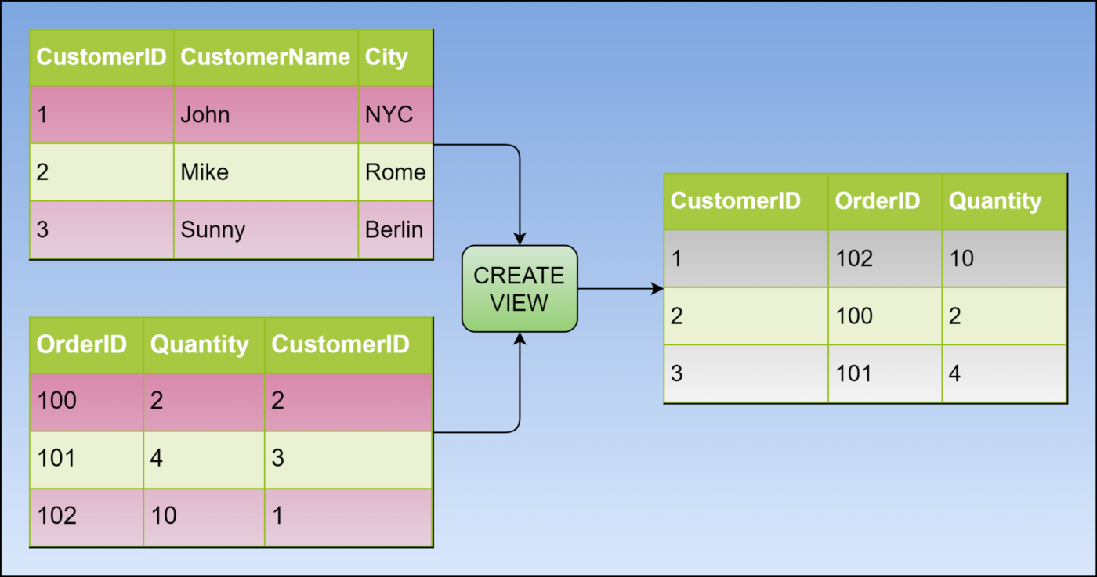

**SCHEMA**

**EVENTS TABLE PARTICIPANT TABLE**

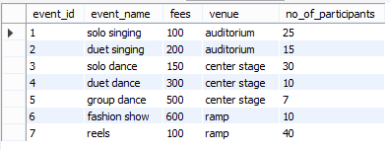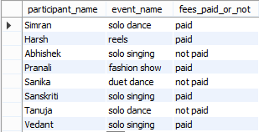

**Before beginning, lets first create a table and insert data.**

Create table ‘events’ having columns event_id,event_name,fees,venue,no_of_participants

This is how our events table should look like

.

**EVENTS TABLE**



**CREATING VIEWS**

We can create View using **CREATE VIEW** statement. A View can be created from a single table or multiple tables.

**Syntax**:

CREATE VIEW view_name AS

SELECT column1, column2.....

FROM table_name

WHERE condition;

**view_name**: Name for the View

**table_name**: Name of the table

**condition**: Condition to select rows

**Creating View from a single table:**

CREATE VIEW DetailsView AS

SELECT NAME, ADDRESS

FROM StudentDetails

WHERE S_ID < 5;

**Q1. Create a view having event name and venue for events having more than 10 participants and venue as center stage.**

**YOUR QUERY HERE:**

**Output:**



**Q2. Create a view having event name and venue for events having venue as auditorium.**

**YOUR QUERY HERE:**

**Output:**



**Creating View from multiple tables**:

CREATE VIEW MarksView AS

SELECT StudentDetails.NAME, StudentDetails.ADDRESS, StudentMarks.MARKS

FROM StudentDetails, StudentMarks

WHERE StudentDetails.NAME = StudentMarks.NAME;

**For creating views from multiple tables, lets create a second table and insert data.**

Create table ‘participant’ having columns, participant_name,event_name, ,fees_paid_or_not

This is how our schema should look like.

**PARTICIPANT TABLE**



**Q3. Create a view from events and participant tables having matching event names.**

**YOUR QUERY HERE:**

**Output:**

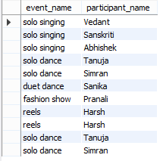

**Q4. Create a view of event name and participant name participating in solo singing event.**

**YOUR QUERY HERE:**

**Output:**

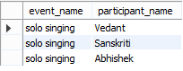

**DELETING VIEWS**

**Syntax**:

DROP VIEW view_name;

**Q5. Delete the view3.**

**YOUR QUERY HERE:**

**Output:**



**UPDATING VIEWS**

1. The SELECT statement which is used to create the view should not include GROUP BY clause or ORDER BY clause.
2. The SELECT statement should not have the DISTINCT keyword.
3. The View should have all NOT NULL values.
4. The view should not be created using nested queries.
5. The view should be created from a single table.

We can use the **CREATE OR REPLACE VIEW** statement to add or remove fields from a view.

**Syntax**:

CREATE OR REPLACE VIEW view_name AS

SELECT column1,coulmn2,..

FROM table_name

WHERE condition;

**Q6. Replace the view2 with participant names who have not paid the fees.**

**YOUR QUERY HERE:**

**Output:**

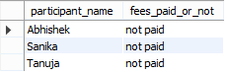

**Inserting a row in a view**:

**Syntax**:

INSERT INTO view_name(column1, column2 , column3,..) VALUES(value1, value2, value3..);

**Q7. Insert a row of values in the view2.**

**YOUR QUERY HERE:**

**Output:**

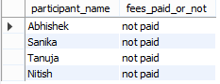

***Congratulations, you have just completed an assignment!!***



**FEEDBACK FORM**:

https://docs.google.com/forms/d/e/1FAIpQLScnAaAKvph9R3vINyCtOOMiav-tSMsRGlJReMaHyPjsXDlTIA/viewform